Practical 6

1. Aim
To perform the following virtual machine management operations using VMware Workstation Pro:
- Clone an existing virtual machine.
- Export a virtual machine as an OVF/OVA image.
- Import the exported VM image.
- Create and manage snapshots.
- Revert a virtual machine to a previous snapshot.

2. Software/Requirements
- VMware Workstation Pro
- A working virtual machine named POV-Lab
- Sufficient disk space for cloned and exported virtual machines
- Host computer running Windows/Linux

3. Theory

Virtual Machine Clone
A clone is an independent copy of an existing virtual machine. It can contain the same operating system, applications, configurations, and virtual disks as the original VM.
Cloning is useful when multiple similar virtual machines are required without installing the operating system and applications from the beginning.

VM Image Export/Import
A virtual machine can be packaged into a portable format such as OVF (Open Virtualization Format) or OVA.
- OVF generally consists of multiple files describing and containing the virtual machine.
- OVA packages the virtual machine into a single archive file.
The exported image can be transferred to another system and imported into compatible virtualization software.

Snapshot
A snapshot records the state of a virtual machine at a particular point in time. It can be used to return the VM to an earlier state after making changes.
Snapshots are useful before performing tasks such as software installation, configuration changes, or testing.

4. Procedure

Part A: Clone the Virtual Machine

Step 1: Open VMware Workstation Pro
- Start VMware Workstation Pro.
- Locate the virtual machine named POV-Lab in the library.

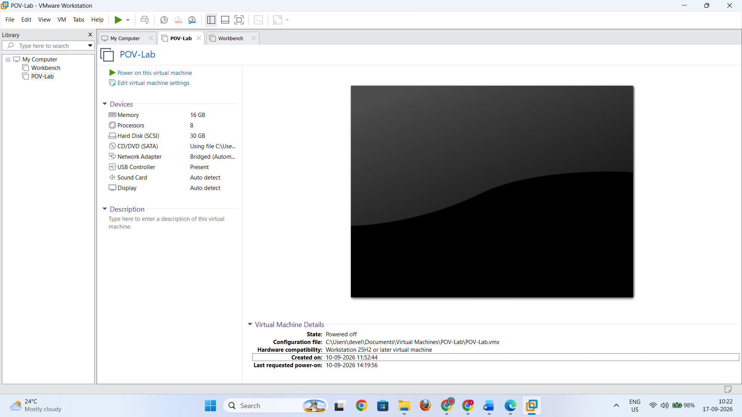

Step 2: Power Off the VM
- If POV-Lab is running, shut down the guest operating system normally.
- Wait until the VM is completely powered off.

Step 3: Start the Clone Operation
- Select POV-Lab.
- Open the VM management options.
- Select Manage → Clone.

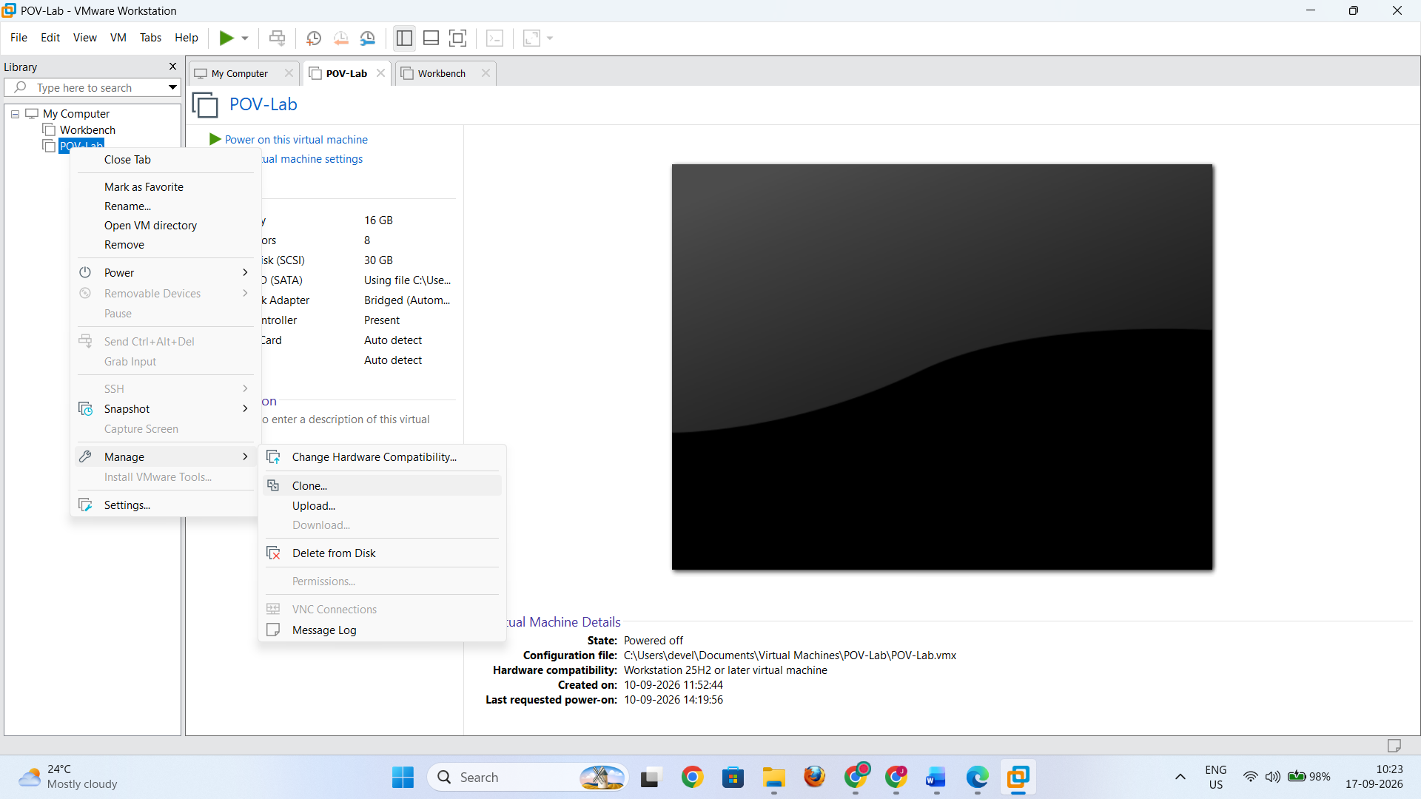
- The Clone Virtual Machine Wizard will open.

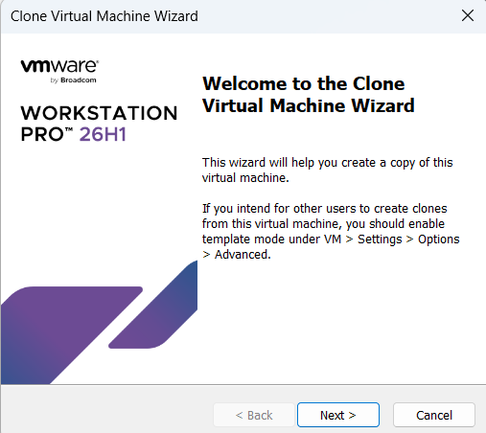

Step 4: Select the Clone Source
Select the appropriate source option, such as:
Current state of the virtual machine

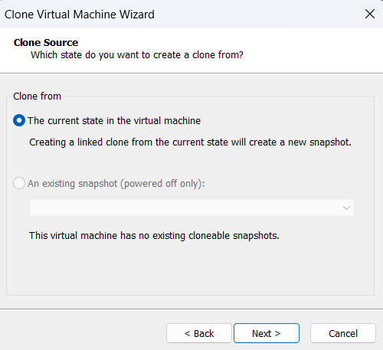
Then click Next.

Step 5: Select Clone Type
Select:
Create a Full Clone
A full clone creates an independent virtual machine rather than relying on the original VM.

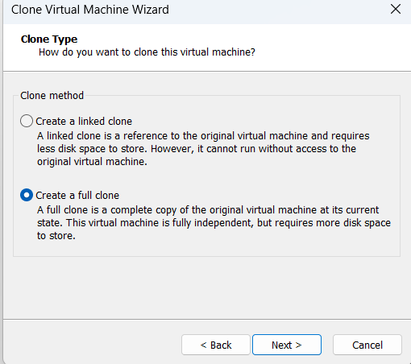
Click Next.

Step 6: Give the Clone a Name
Enter a name such as:
POV-Lab-Clone
Select a suitable location where the cloned VM will be stored.

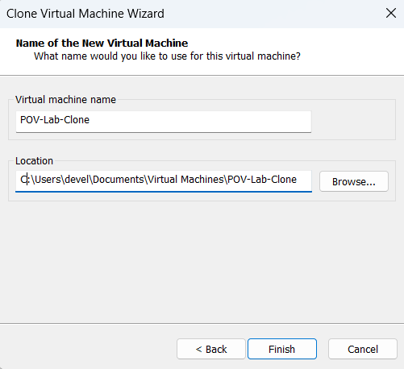
Click Finish.

Step 7: Verify the Clone

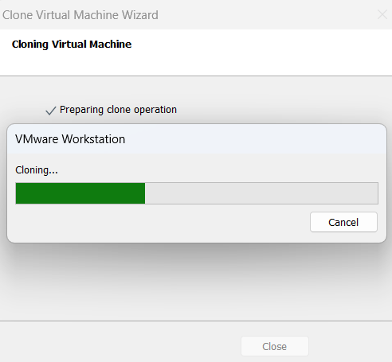

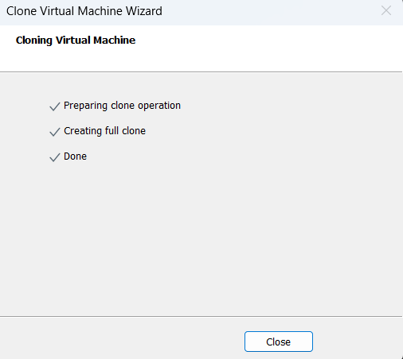
After the cloning process is complete:
- Check that POV-Lab-Clone appears in VMware Workstation Pro.

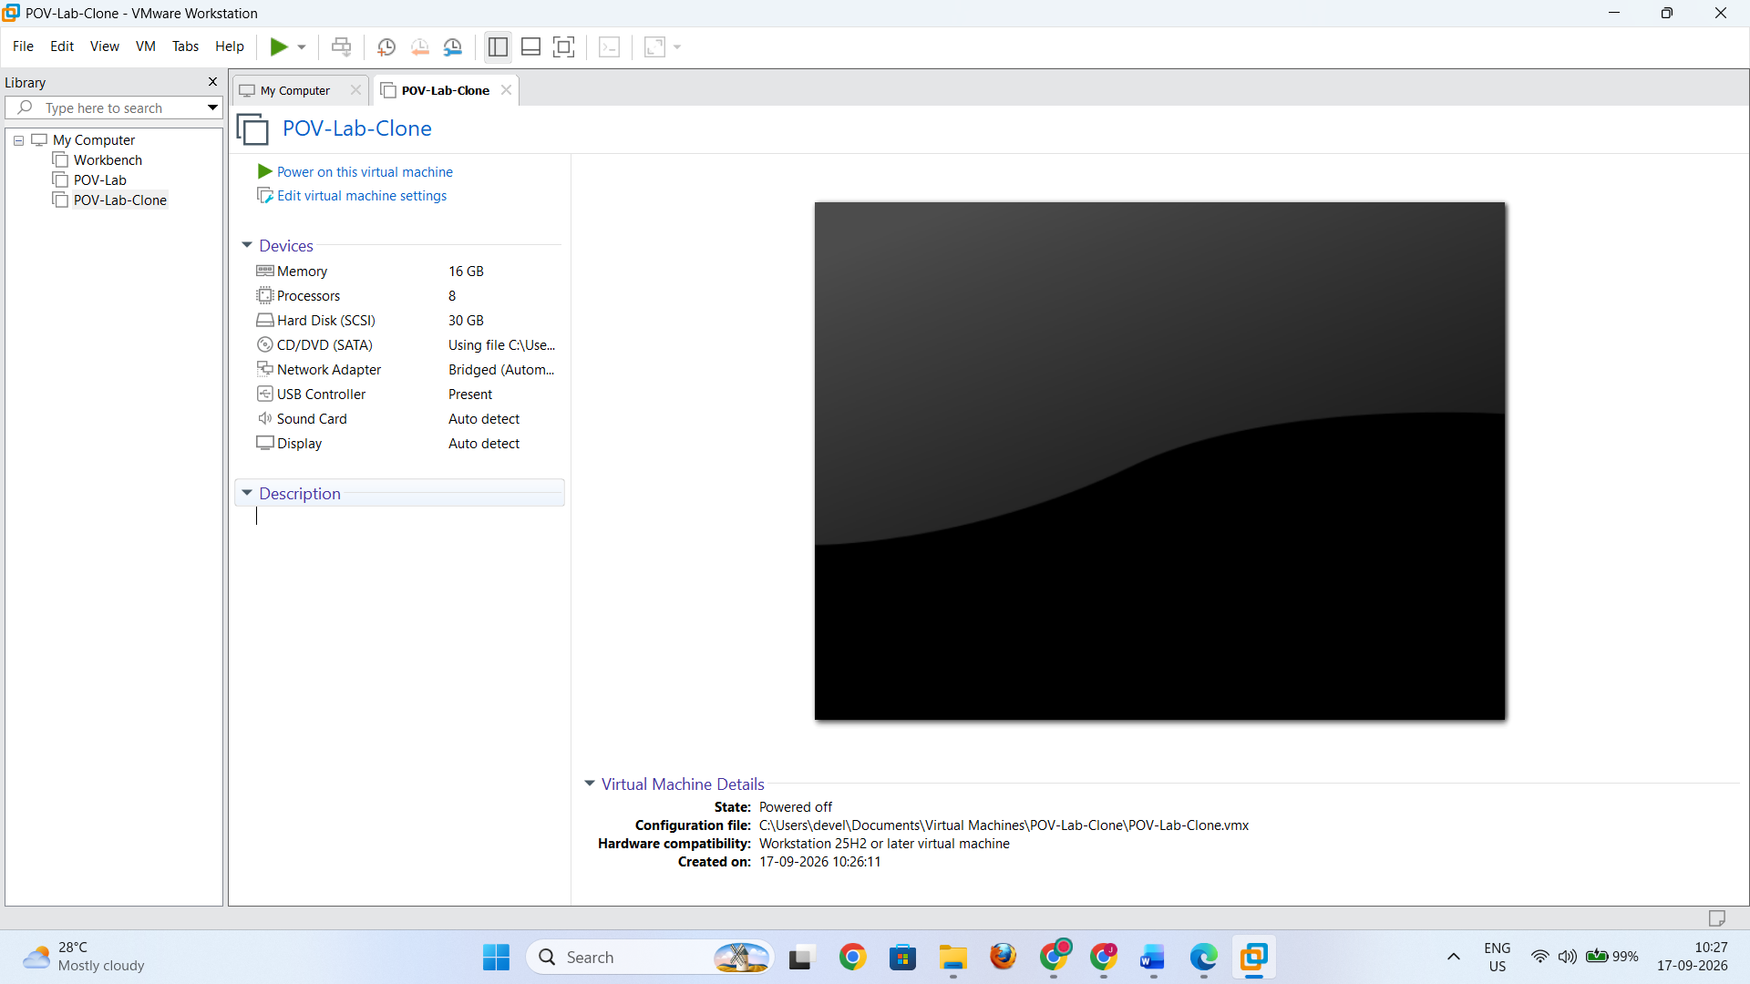
- Power on the cloned VM.
- Verify that the operating system starts successfully.
- Check that the applications and configurations are present.

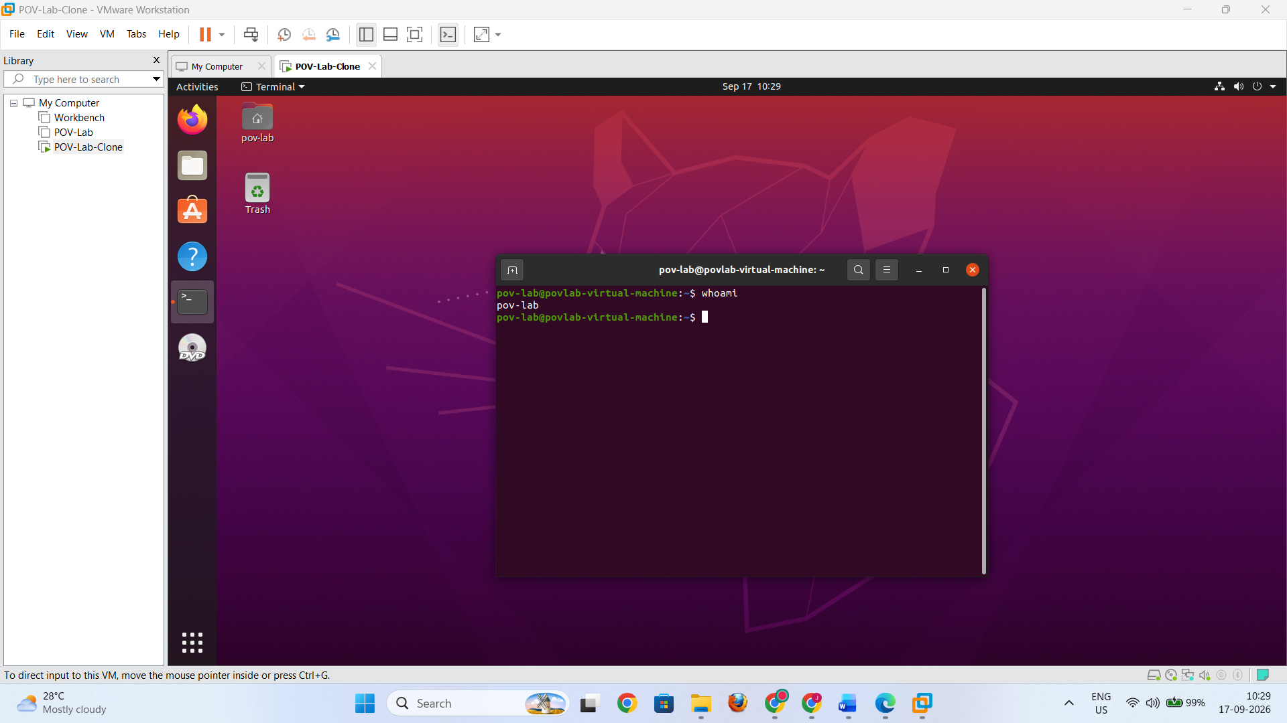

Observation
The original VM POV-Lab remains unchanged, while POV-Lab-Clone works as a separate virtual machine.

Part B: Export the Virtual Machine

Step 1: Select the VM
- Open VMware Workstation Pro.
- Select POV-Lab or the VM that you want to export.

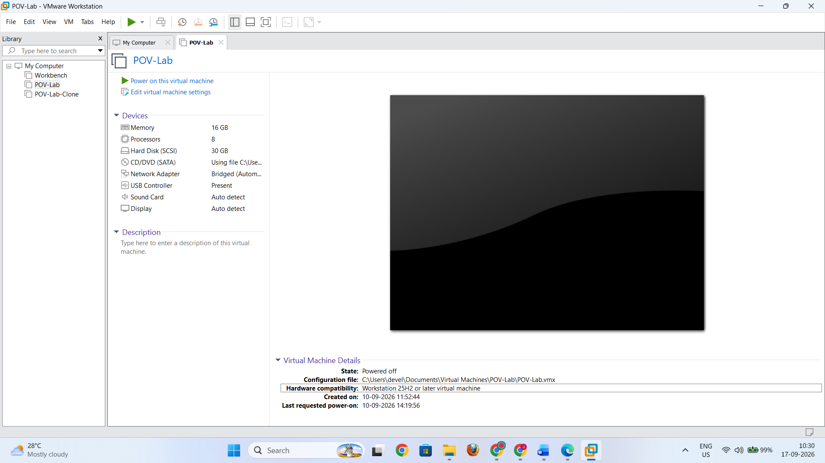
- Ensure that the VM is powered off.

Step 2: Start Export
Depending on the VMware Workstation Pro version, use the available option for exporting the virtual machine:
File → Export to OVF

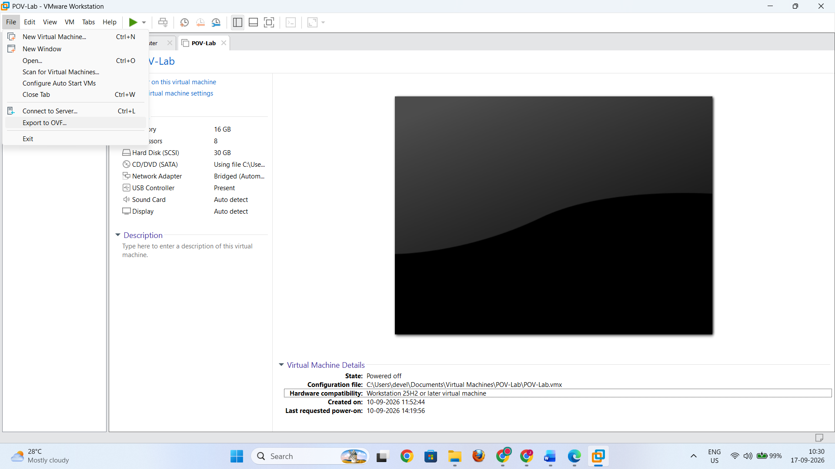

Step 3: Select the Destination
Choose a folder where the exported VM will be stored.
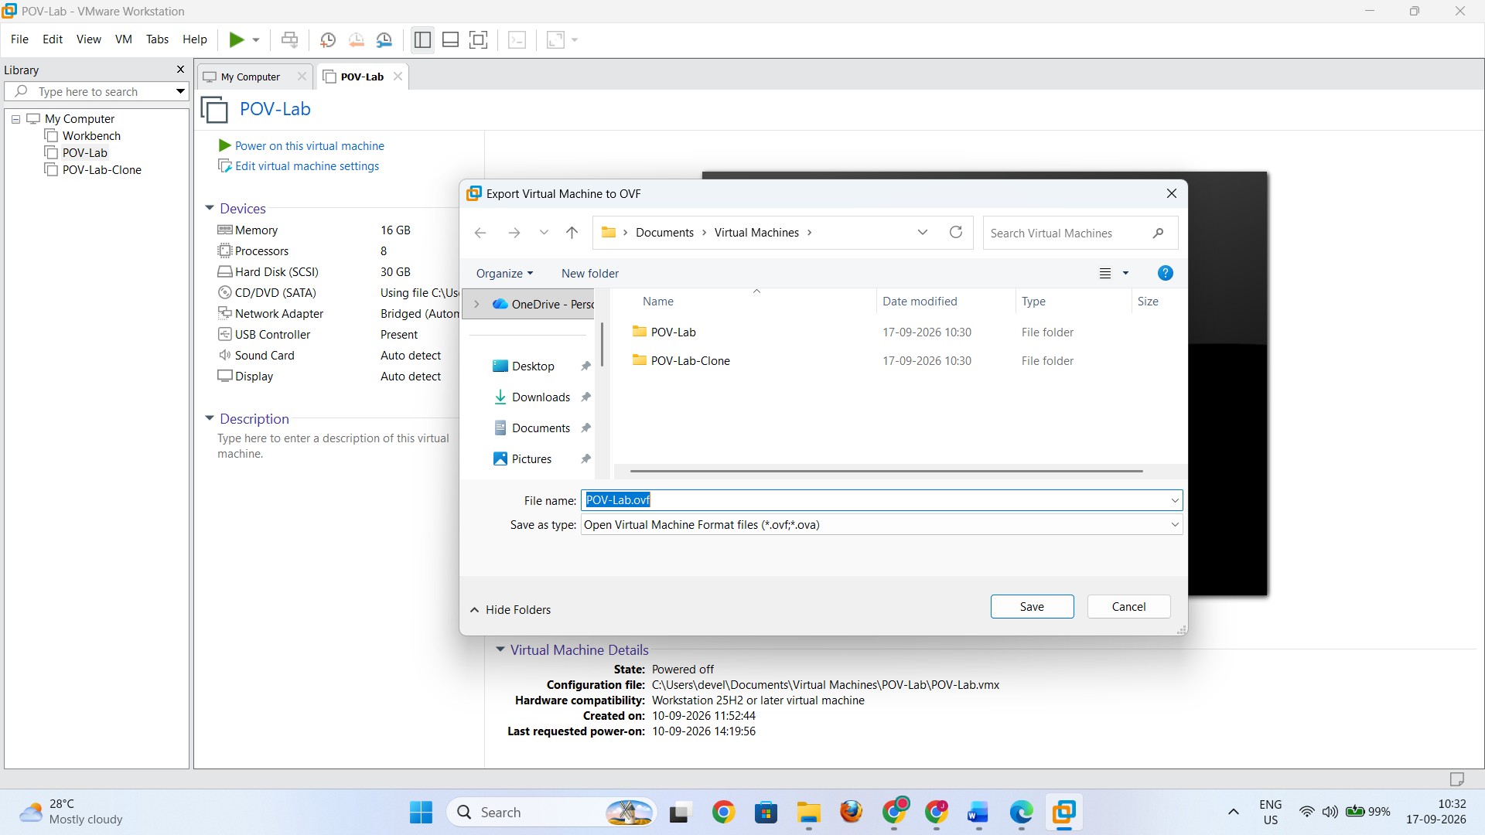
Start the export operation.

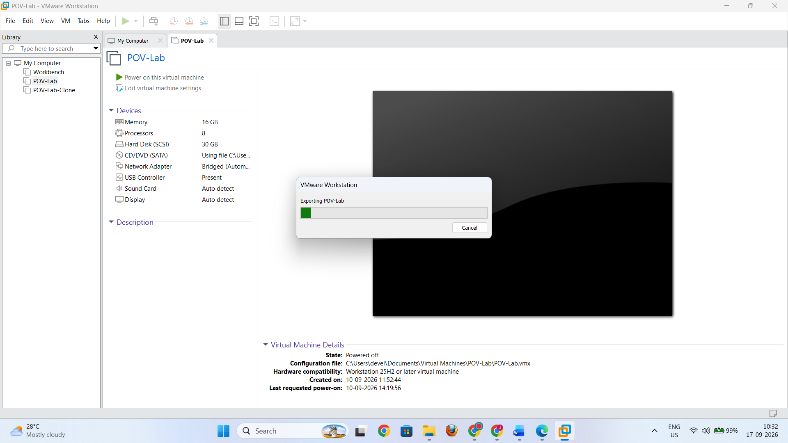

Step 4: Wait for Export to Complete
VMware creates the required files for the virtual machine image.
An OVF export may contain files such as:
- .ovf — VM description/configuration
- .vmdk — virtual disk
- .mf — manifest file, when generated
An OVA export packages the required VM components into a single .ova file.

Step 5: Verify the Export
Open the destination folder and confirm that the exported VM files have been created successfully.

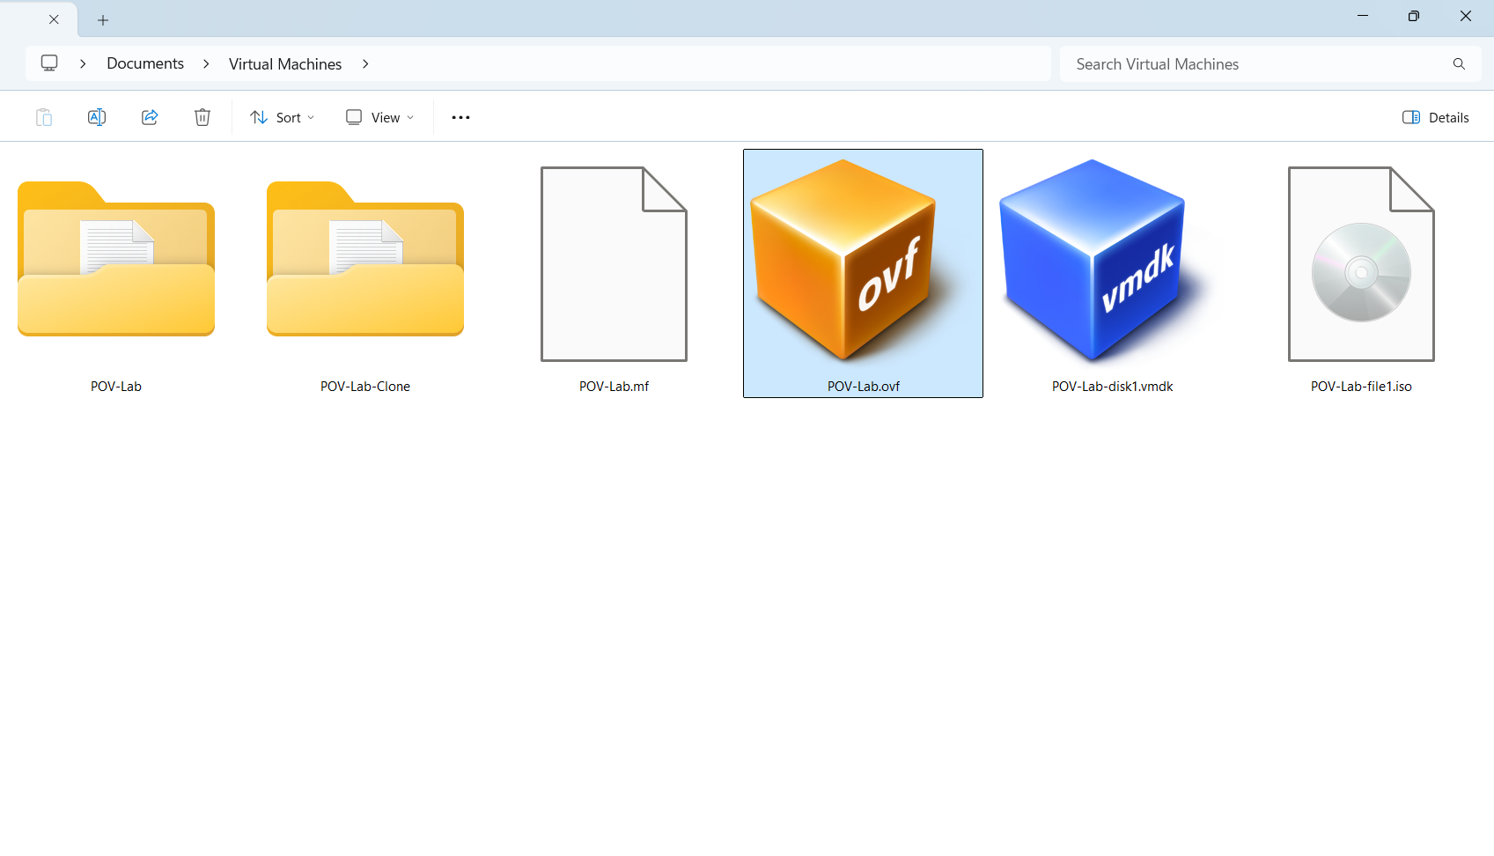

Observation
The POV-Lab virtual machine was successfully converted into a portable virtual machine image.

Part C: Import the Virtual Machine Image

Step 1: Open VMware Workstation Pro
Start VMware Workstation Pro on the same computer or another compatible computer.

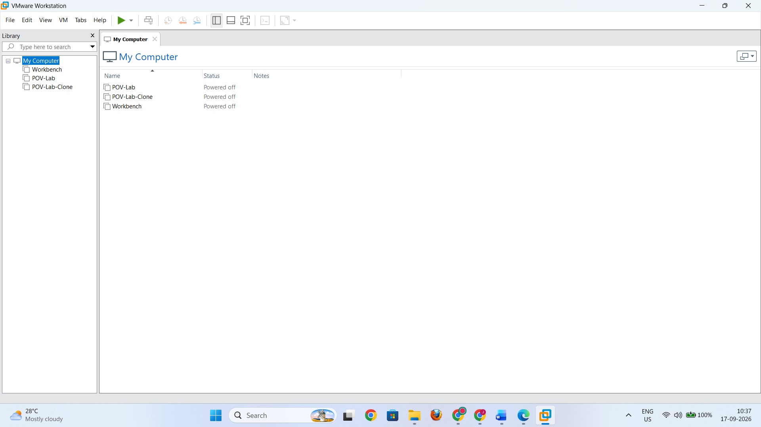

Step 2: Open the OVF File
Open the destination folder where the OVF file was exported.
Select the exported file:
POV-Lab.ovf
Right click on the file and select Open with VMWare Workstation

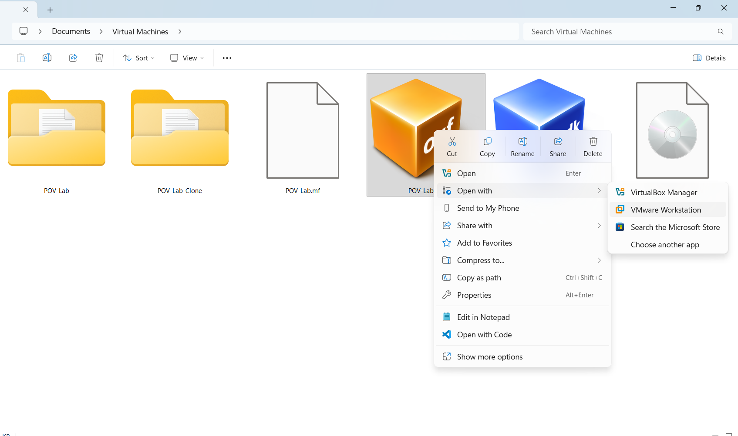

Step 3: Select Storage Location
Choose a suitable location where the imported virtual machine will be stored.

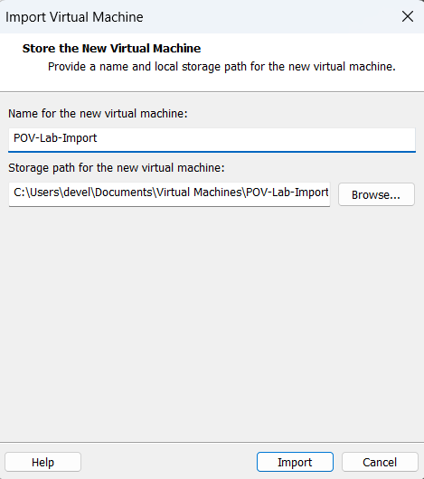

Step 4: Start Import
Confirm the import settings and start the operation.
VMware extracts the virtual disks and VM configuration from the exported image.

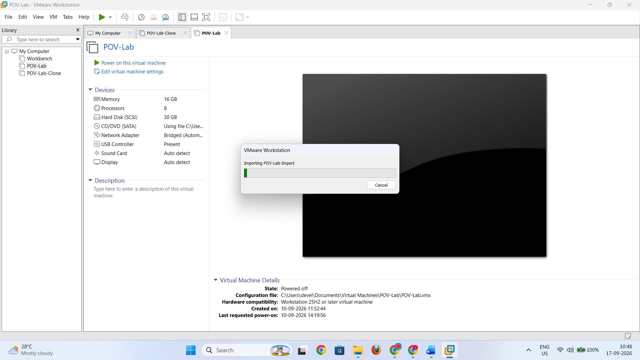

Step 5: Verify the Imported VM
After the import is complete:
- Check that the VM appears in VMware Workstation Pro.

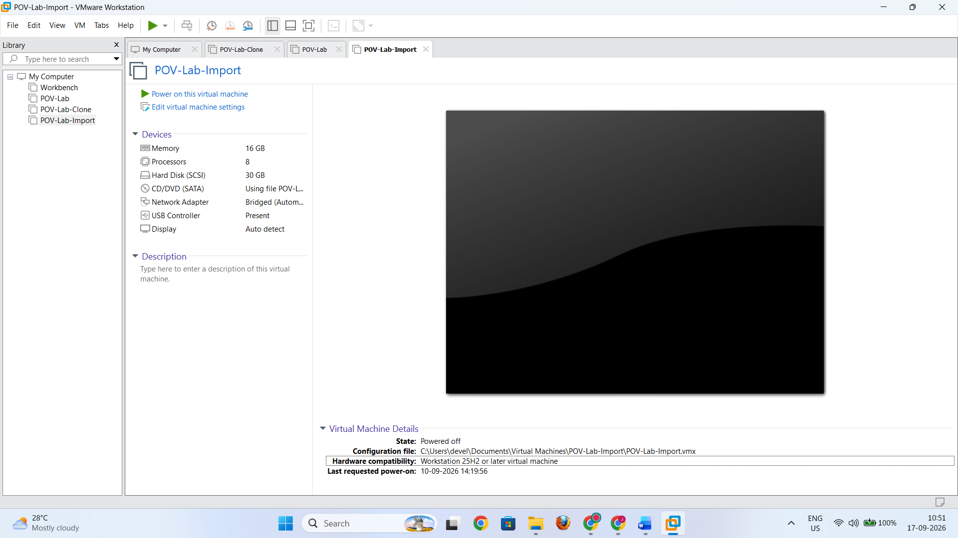
- Power on the imported VM.
- Verify that the guest operating system boots correctly.
- Check important applications and configurations.

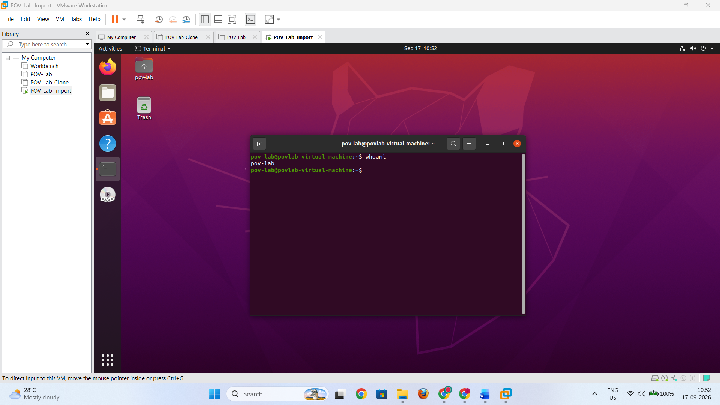

Observation
The exported VM image was successfully imported and restored as a virtual machine.

Part D: Snapshot Management

1. Create a Snapshot
- Select POV-Lab in VMware Workstation Pro.

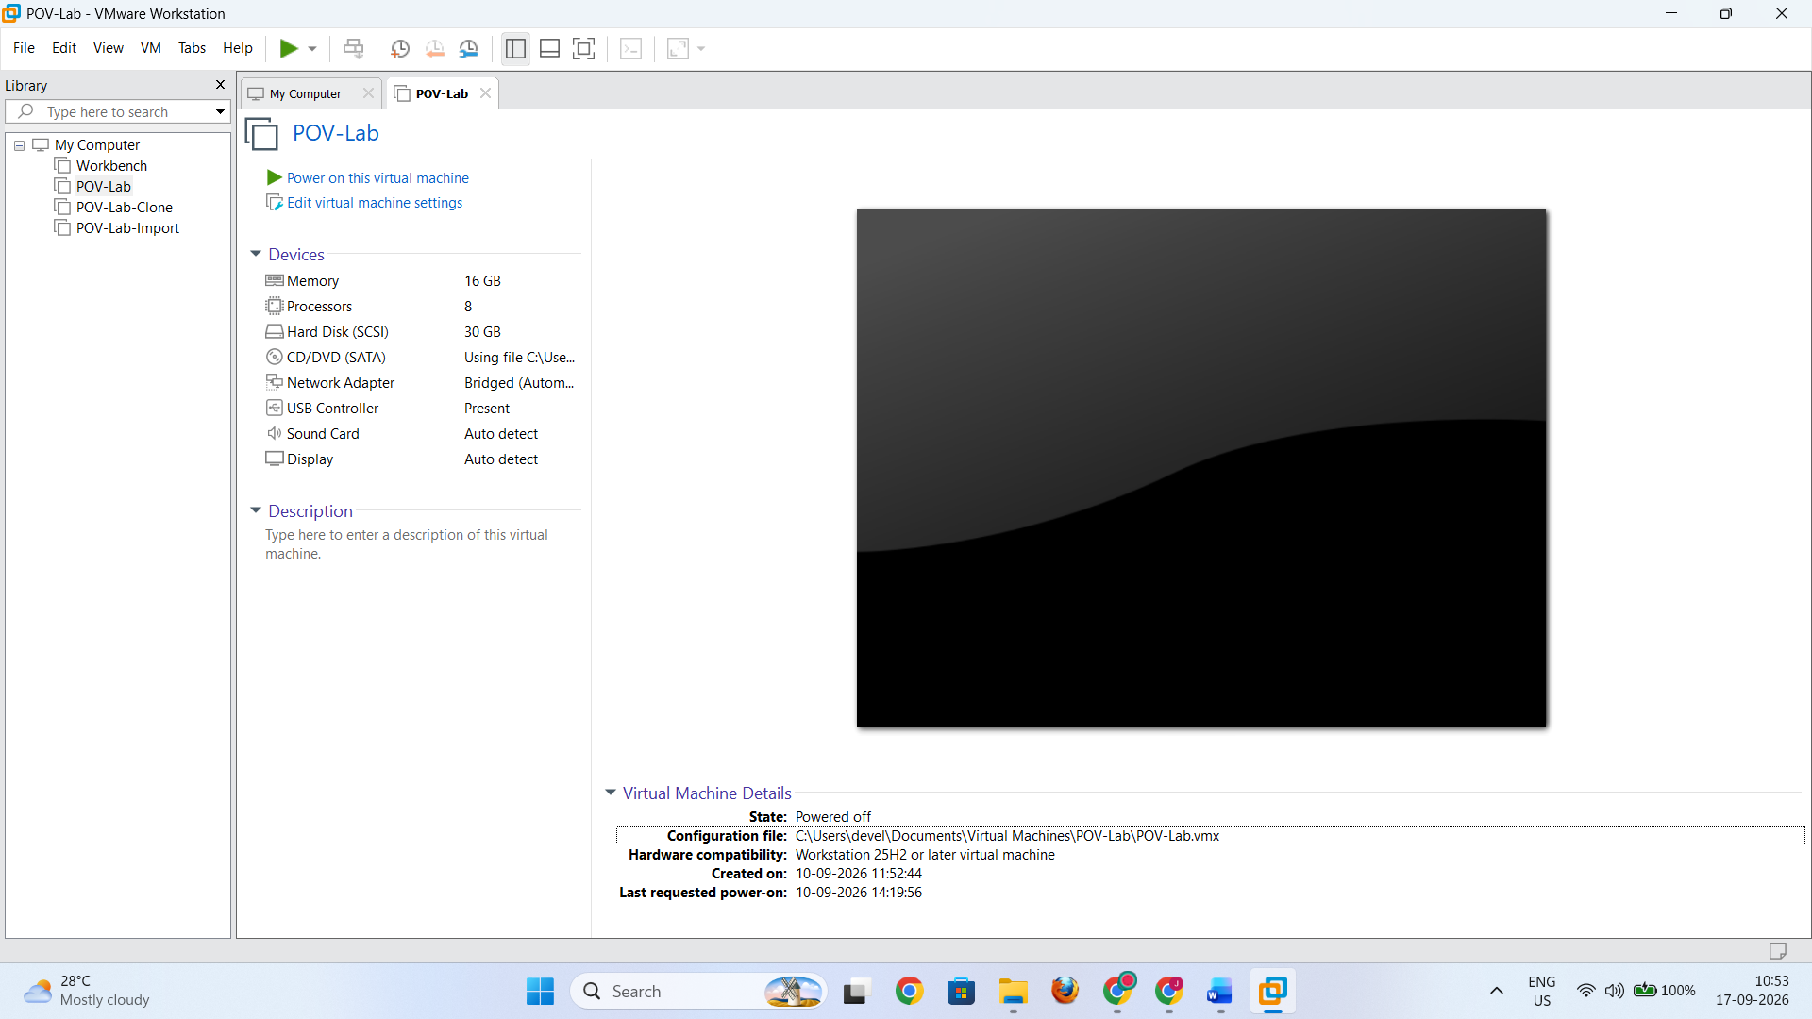
- Right click on the VM name.
- Go to Snapshot
- Select Take Snapshot.

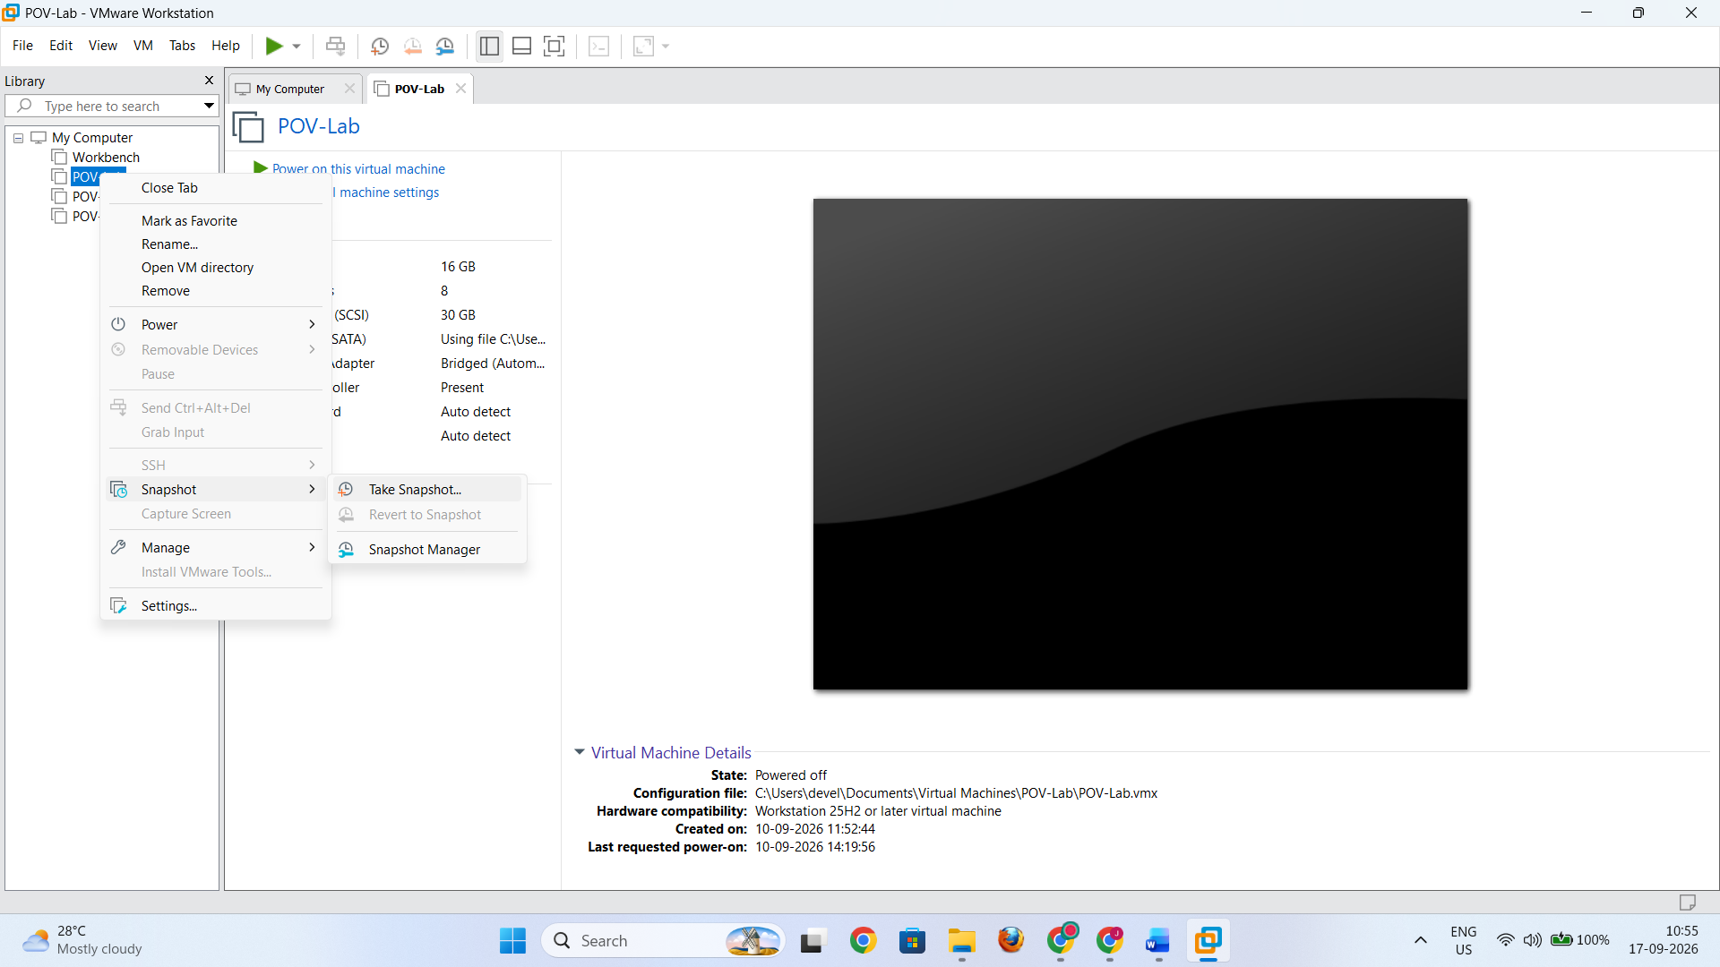
- Enter a name, for example:
Before_Configuration

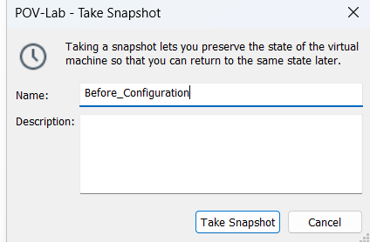
- Add a description if required.
- Click Take Snapshot.
The snapshot now represents the VM's state at that point.

2. Make Changes to the VM
After creating the snapshot, perform a small test change inside POV-Lab, such as changing a configuration or creating a test file.

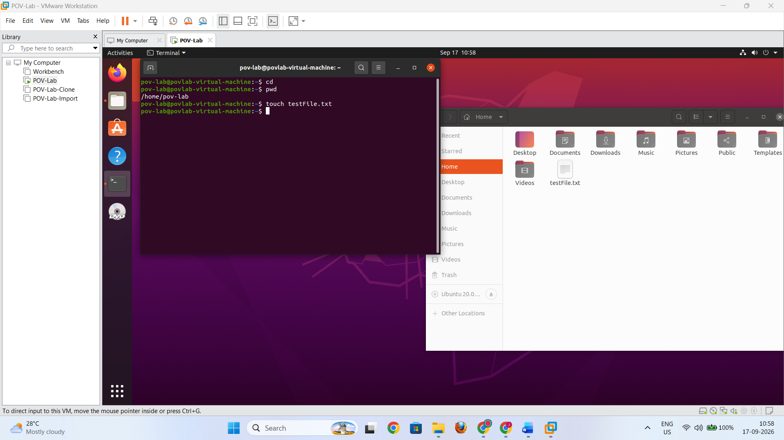

3. Revert to a Snapshot
- Turn off the POV-Lab Virtual machine.
- Again, right click the VM.
- Choose SnapshotRevert to Snapshot: Before_Configuration

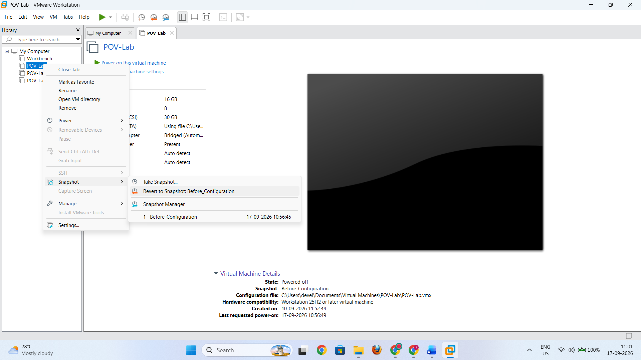
- Confirm the operation if VMware asks for confirmation.

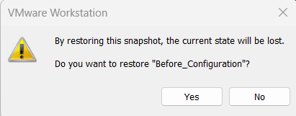
The VM returns to the state represented by the selected snapshot.

Observation
Changes made after the snapshot was created are no longer present when the VM is reverted to that earlier snapshot state.

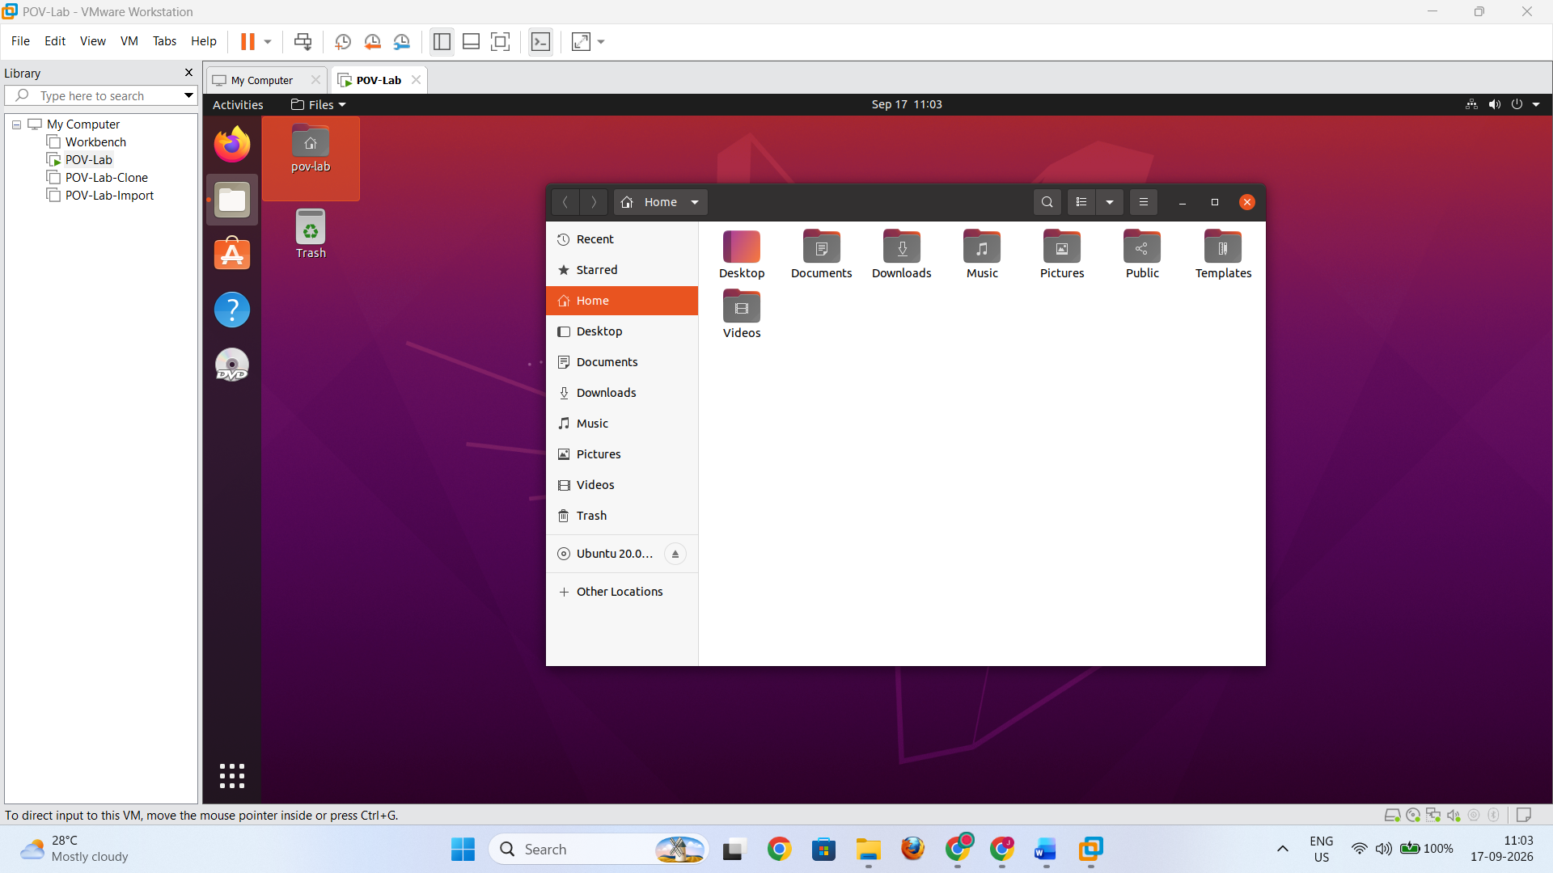

4. Snapshot Management Operations
Common snapshot operations available in VMware Workstation Pro include:
Operation | Purpose
Take Snapshot | Saves the current state of the VM
Revert/Go To Snapshot | Returns the VM to a previous snapshot state
Delete Snapshot | Removes a snapshot
Snapshot Manager | Displays and manages snapshots
Snapshot Tree | Shows relationships between snapshots

5. Precautions
- Ensure that sufficient disk space is available before cloning or exporting a VM.
- Give meaningful names to cloned VMs and snapshots.
- Avoid keeping unnecessary snapshots for a long period because they can consume significant disk space.
- Do not delete the original VM while an operation is in progress.
- Verify the exported image after the export operation.
- Before deleting a snapshot, confirm that it is no longer required.
- Keep important VM files backed up before performing major changes.

6. Result
The following virtual machine management operations were successfully performed using VMware Workstation Pro:
- POV-Lab was cloned to create an independent virtual machine.
- The virtual machine was exported as an OVF/OVA image.
- The exported VM image was imported back into VMware Workstation Pro.
- Snapshots were created and managed.
- The virtual machine was reverted to a previously created snapshot.
Thus, VM cloning, VM image export/import, and snapshot management were successfully demonstrated.

